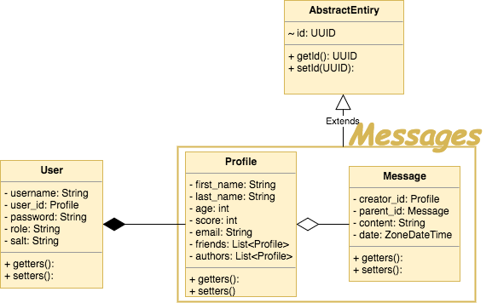

Rest Services

UserService:

* createUser(User): boolean
* changePassword(User, String)
* changeRole(User, String): boolean

ProfileService:

* createProfile(Profile): boolean
* updateProfile(Profile): boolean
* updateProfileFriend(List<Profile>): boolean
* updateProfileAuthor(List<Profile>): boolean

MessageService:

* saveMessage(Message): boolean
* getMessages(Profile): List<Message>
* messagePublishAlert(List<Profile>) = alert users of publish stories by their favorite authors.
* reviewMessageAlert(Profile,Message,Episode): List<Message>-> notification of received messages